**Practice Set 7**

**1. List out features :**

* Seller should be able to register himself with unique id, contact number, address and products
* Customer should be able to register himself with unique email address, contact number, address.
* Customer should be able to login, search for products listed by seller, add to cart, buy and logout.
* Details of all transactions should get recorded for future use.
* For products that are out of stock, the customer should get a notification if the product is in his wish list and is now available.
* Any customer should be able to search a product on the basis of name, detail and category.
* Customer should be able to add or delete a product from in wishlist.
* Customer should be able to add or delete product from cart.
* Seller must be allowed to add ,delete ,update product details.

**2. Draw Use case diagrams :**

The top use cases of the Amazon design:

* **Add/Remove/Edit product :** To add, remove or modify a product or product item.
* **Search catalog:** To search products by name, detail, category.
* **Register new customer:** To add a new customer.
* **Register new seller:** To add a new seller.
* **Add to cart:** Add /Remove product from cart.
* **Add to wish list:** Add /Remove product from wish list.
* **Place order:** Place order for products in cart.
* **Notification:** Get notification if product in wish list is out of stock or available.

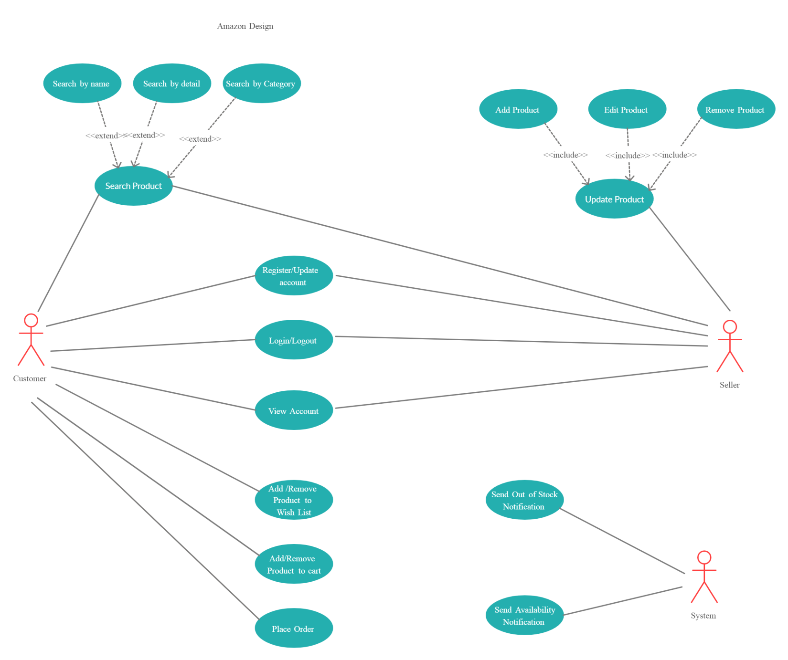

**Fig: Amazon Design Use Case Diagram**

**Class diagram**

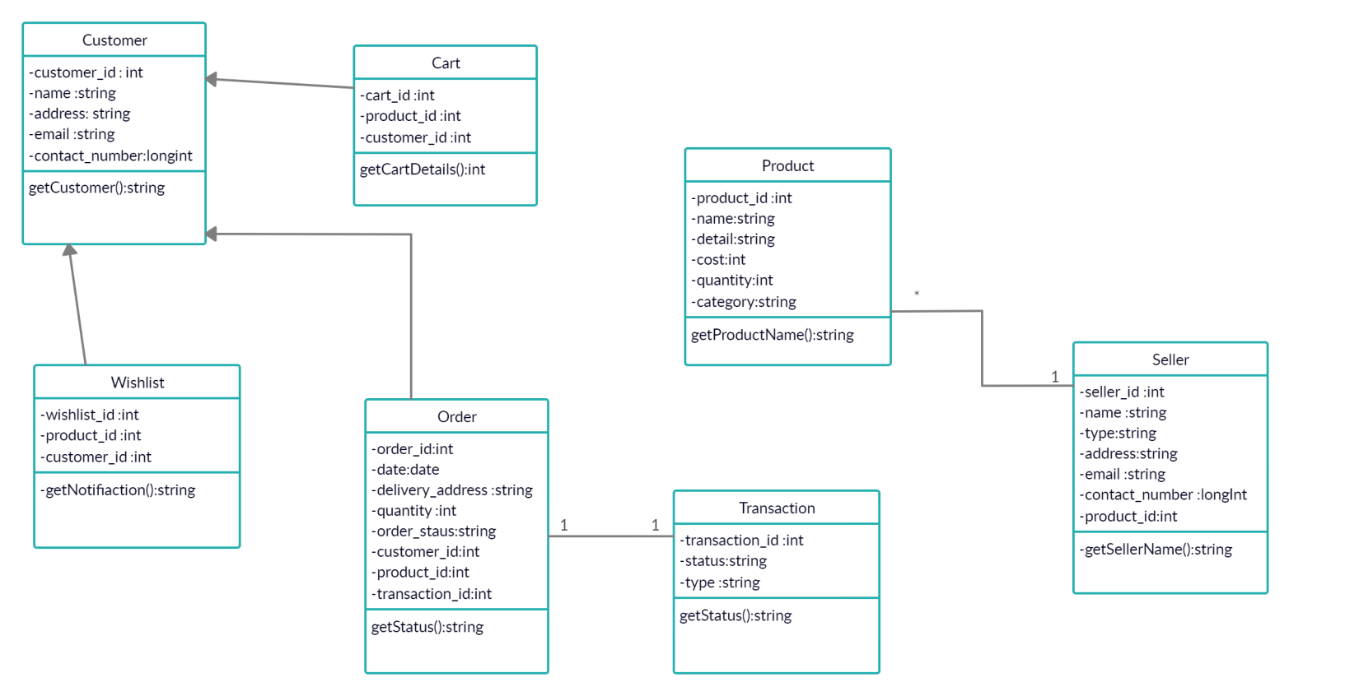

**Design patterns that can be applied for the functionalities.**

**Cart** : Status design pattern

**Wish list :** Observer design pattern